VPC Transit Gateway & VPC Endpoint
1. Create one VPC, with 1 public subnet and 1 private subnet.

Objective
To create an AWS Virtual Private Cloud (VPC) containing:
- 1 Public Subnet
- 1 Private Subnet
- Internet Gateway (IGW)
- Route Tables for public and private subnets
- Proper subnet associations

Prerequisites:
- AWS Account
- AWS Management Console access
- Basic knowledge of AWS networking

Step-1 Step-by-Step Procedure:

Login to AWS Console
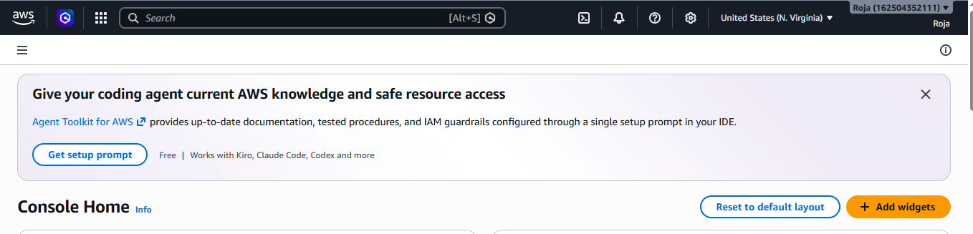
Step-2 Open VPC Dashboard

- Search for VPC in the AWS Console.
- Click VPC under services
- Go to Your VPC’s and Click on Create VPC.
- Enter the following details

Select VPC only, Name : MY-VPC, IPV4 CIDR : 10.0.0.0/16, IPV6 : None, Tenancy : Default.
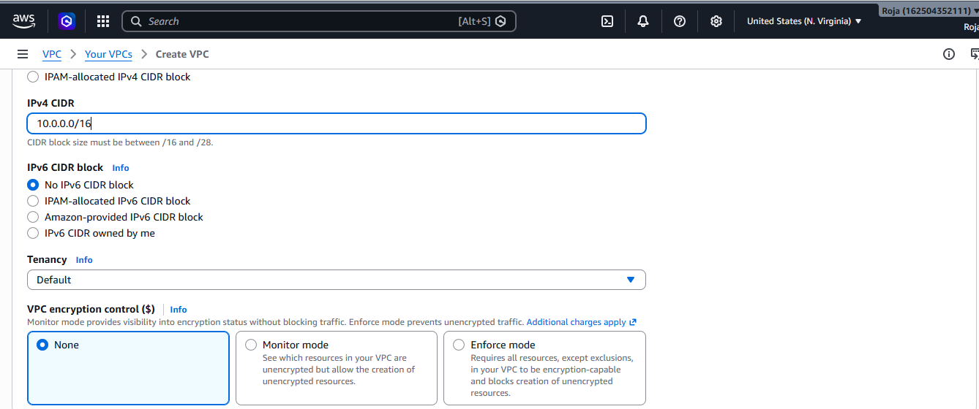

Successfully created VPC:

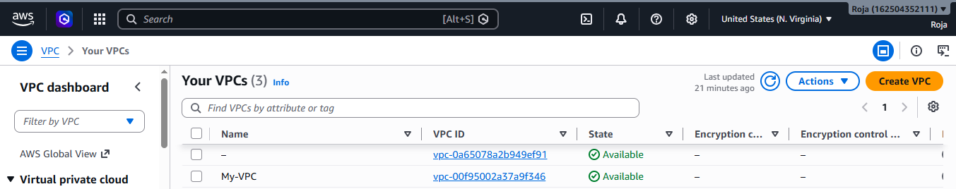

Step-3: Create the Public Subnet
- In the VPC Dashboard, click Subnets.
- Click Create subnet.
- Select My-VPC.
- Enter the details:
Name: Public Subnet, Availability Zone: us-east-1a, Ipv4 CIDR : 10.0.1.0/24
5. Click on Create Subnet.

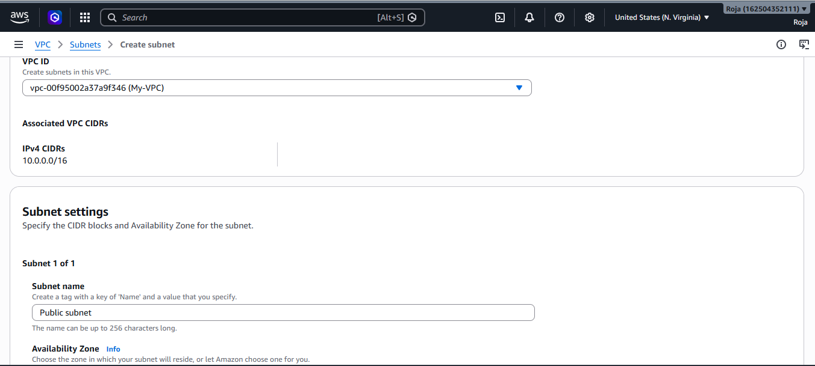

Successfully created public subnet:
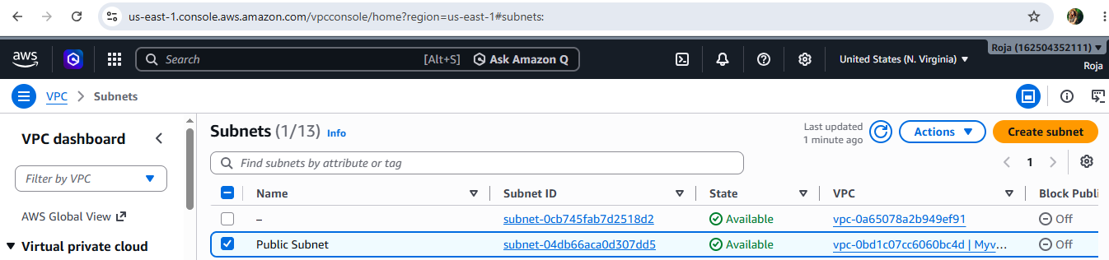

Step-4: Enable Auto-Assign Public IP
- Select Public-Subnet.
- Click Actions → Edit subnet settings.
- Enable Auto-assign public IPv4 address.
- Save the changes.
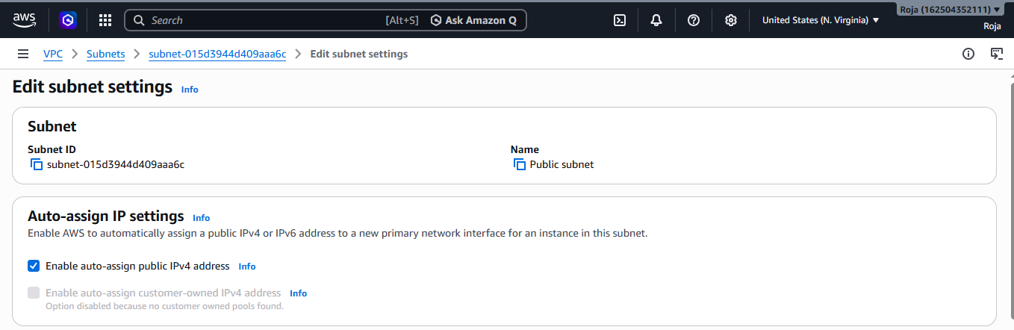

Step-5: Create the Private Subnet
- In the VPC Dashboard, click Subnets.
- Click Create subnet.
- Select My-VPC.
- Enter the details:
Name: Private Subnet, Availability Zone: us-east-1b, Ipv4 CIDR : 10.0.2.0/24
5. Click on Create Subnet.

Successfully created private subnet:
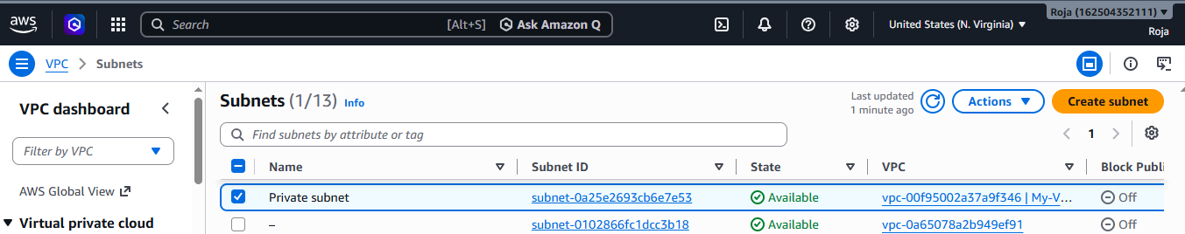
Expected Result:
Instances launched in the public subnet automatically receive a public IP

Step 6: Create an Internet Gateway
- Go to Internet Gateways.
- Click Create internet gateway.
- Name it My-IGW.
- Click Create Internet Gateway.

Step 7: Attach the Internet Gateway
- Select My-IGW.
- Click Actions → Attach to VPC.
- Choose My-VPC.
- Click Attach.
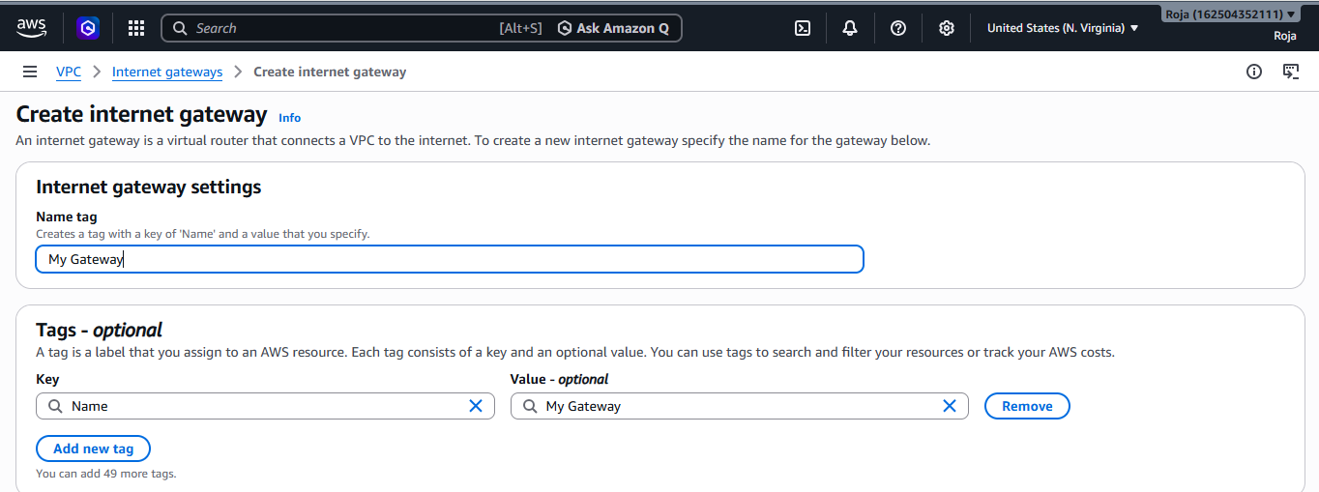
Created Internet Gateway and attached to VPC: 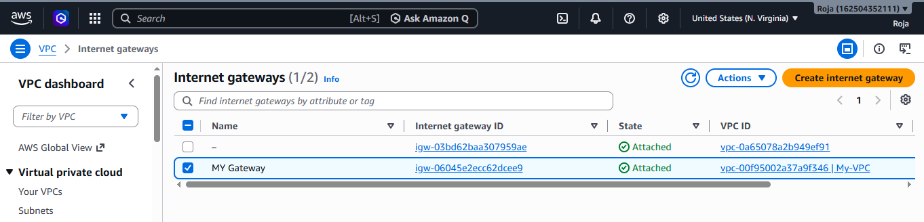

Step 8: Create Public Route Table
- Navigate to Route Tables.
- Click Create Route Table.
- Enter details:
Name : MY route, VPC : My-VPC
4. Click Create Route Table
Step 9: Add Internet Route

- Open Public-RT.
- Select Routes → Edit Routes.
- Click Add Route.
- Save changes.
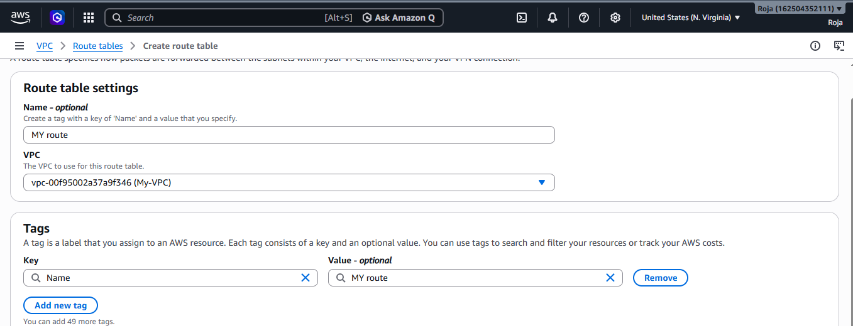

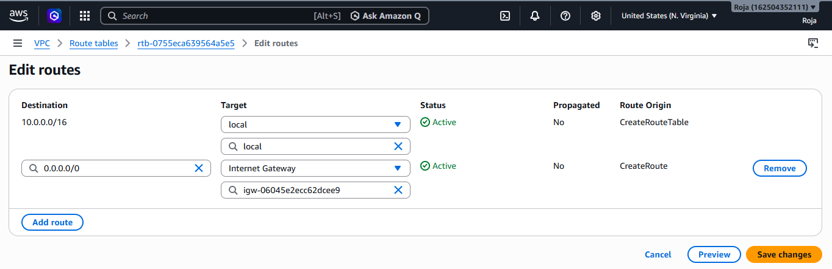

Step 10: Associate Public Subnet
- In Public-RT, select Subnet Associations.
- Click Edit Subnet Associations.
- Select Public-Subnet.
- Save the changes.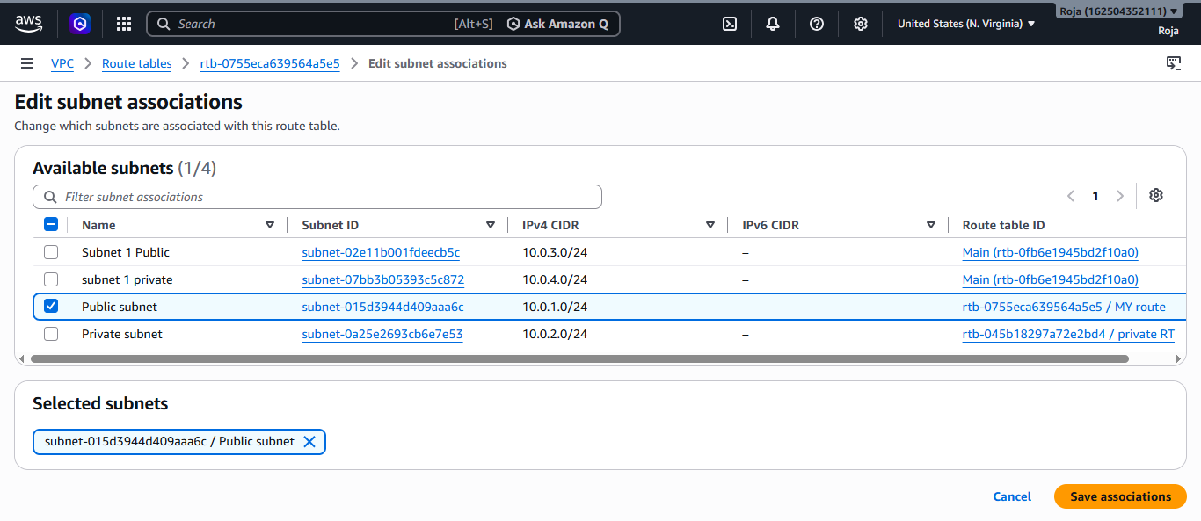

Step 11: Create Private Route Table
- Click Create Route Table.
- Enter details:
Name: private RT, VPC: My-VPC
3. Click create Route table

Expected Result:
Public subnet now has internet access.

Step 12: Associate Private Subnet
- Open Private-RT.
- Select Subnet Associations.
- Click Edit Subnet Associations.
- Select Private-Subnet.
- Save association.
Do not add an Internet Gateway route to the private route table.
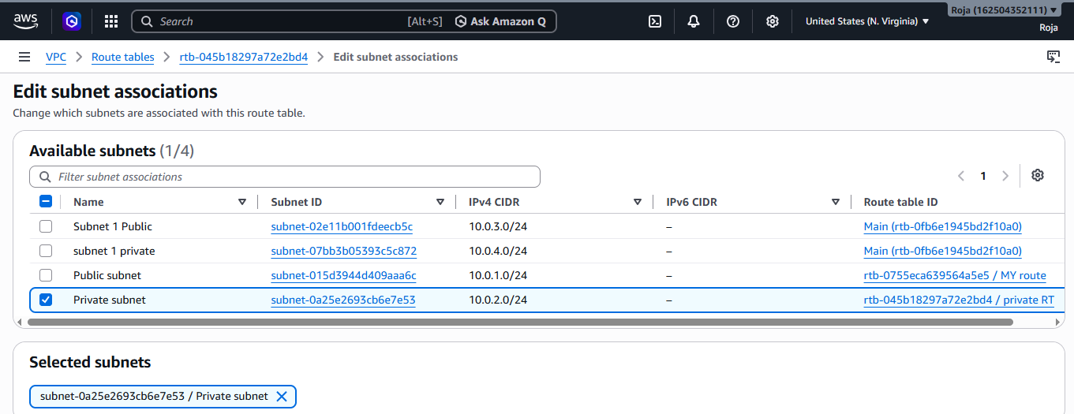

Task: 2. Enable VPC peering for cross-region.

Objective
To establish a cross-region VPC peering connection between two Amazon VPCs located in different AWS Regions, allowing private communication between resources in both VPCs.

Prerequisites
- AWS Account
- Access to the AWS Management Console
- Two VPCs created in different AWS Regions
- Non-overlapping IPv4 CIDR blocks for both VPCs
- Appropriate IAM permissions to create and accept VPC peering connections

VPC-1 (Requester) North Virginia us-east-1 10.0.0.0/16
VPC-2 (Accepter) North California us-west-1 192.168.0.0/16

Step-by-Step Procedure

Step 1: Create Two VPCs
- Sign in to the AWS Management Console.
- Create the first VPC in Region 1 (for example, us-east-1).
- Create the second VPC in Region 2 (for example, us-west-1).
- Ensure that both VPCs use different CIDR blocks.
Created First VPC in us-east-1
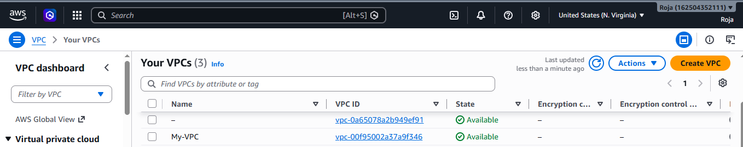

Created Second VPC in us-west-1
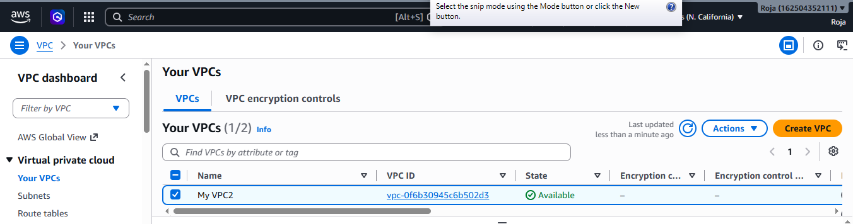

Step 2: Open the VPC Dashboard
- Select the requester region (for example, us-east-1).
- Navigate to VPC Dashboard.
- In the left navigation pane, select Peering Connections.

Step 3: Create a VPC Peering Connection
- Click Create Peering Connection.
- Enter the following details:
- Name : Cross Region Peering, Requester VPC : VPC1, Account : My account, Region : Another region, Accepter region : us-west-1, Accepter VPC : My VPC2
- Click Create Peering Connection.
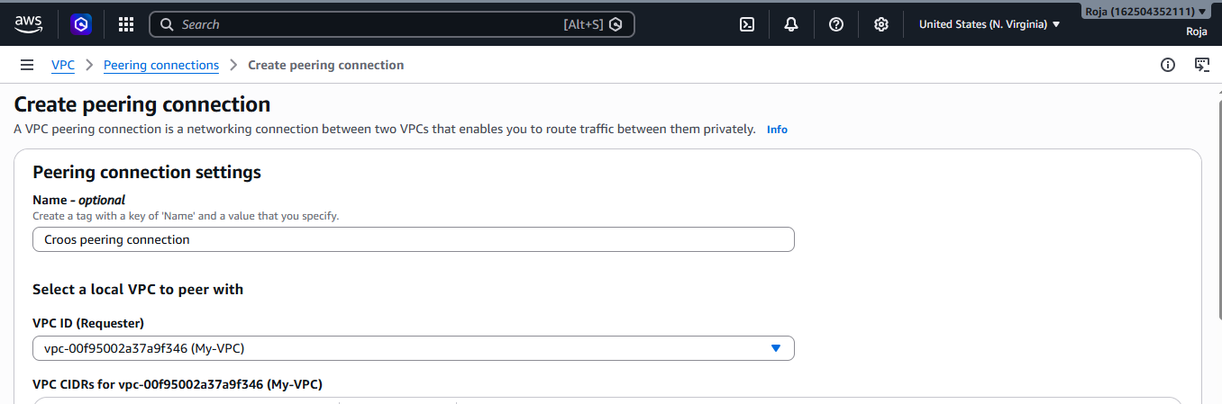
VPC cross peering connection is requested in us east 1 region
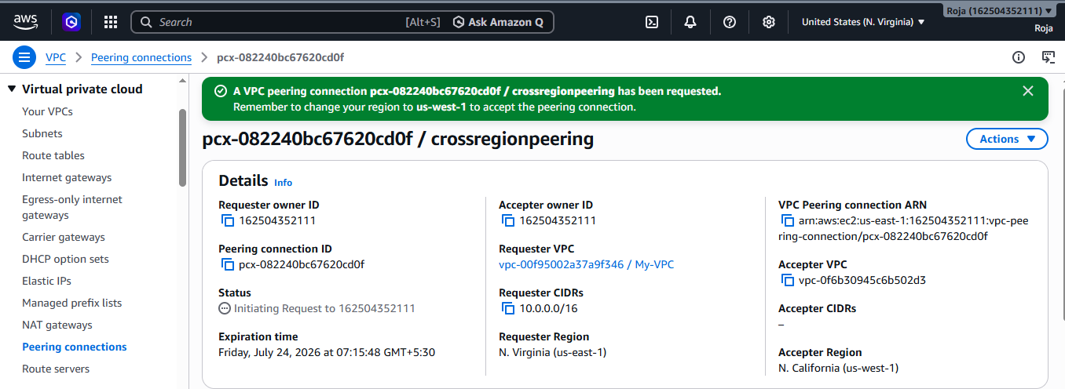

Expected Result: The peering connection status displays as Pending Acceptance.

Step 4: Accept the Peering Request
- Switch to the accepter region (us-west-1).
- Open VPC Dashboard → Peering Connections.
- Select the pending peering request.
- Click Actions → Accept Request.
- Confirm the request.
Expected Result: The connection status changes to Active.
Accepted the cross peering connection us west 1 region:
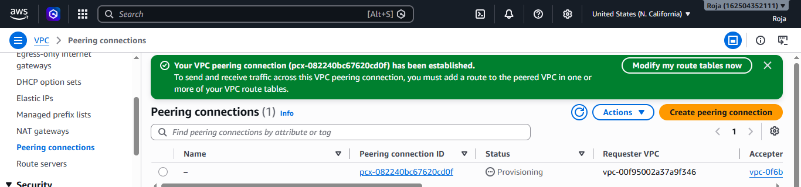

Step 5: Update Route Table for VPC-1 & VPC-2
- Navigate to Route Tables.
- Select the route table associated with the subnet in VPC-1 & VPC-2.
- Click Routes → Edit Routes.
- Add VPC Peering Connection route
- Save the route
Below is the updated route table for VPC-1 in region 1
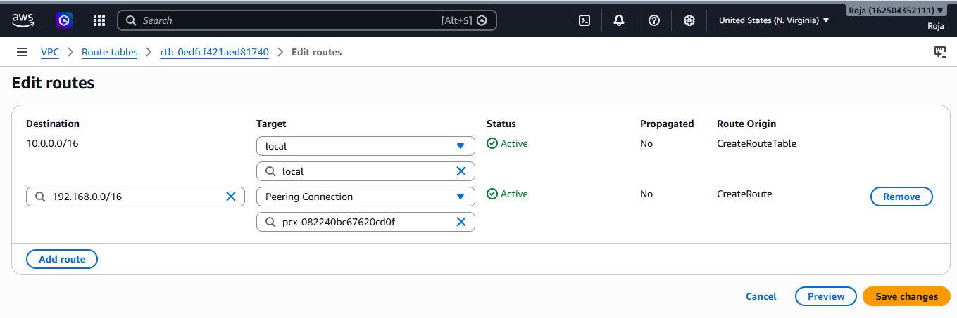
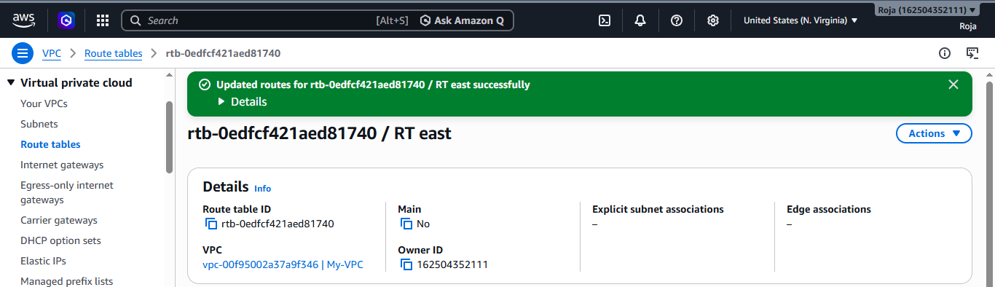
Below is the updated route table for VPC-2 in region 2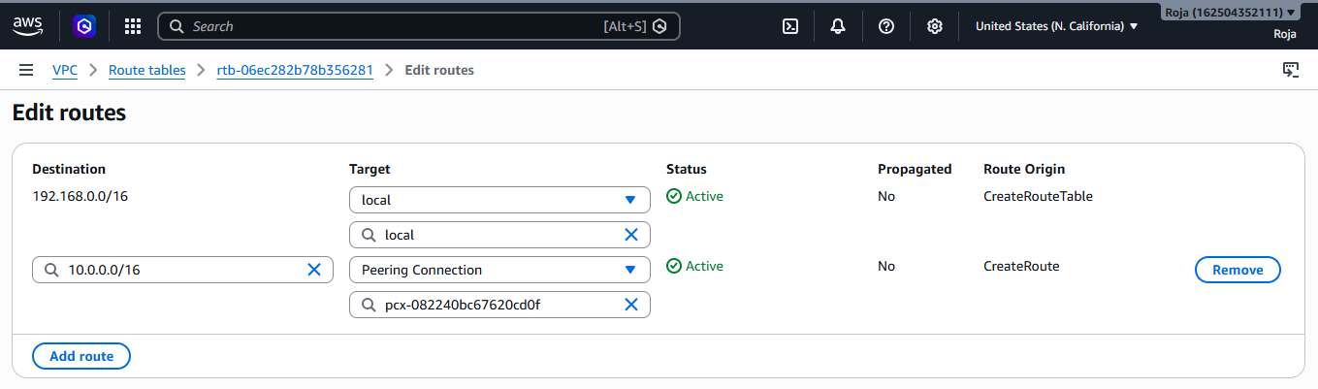
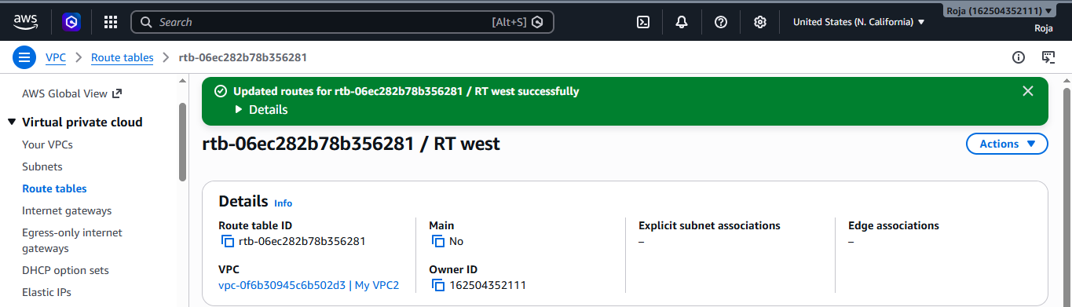

Connected to ec2 using ssh and tested connection:
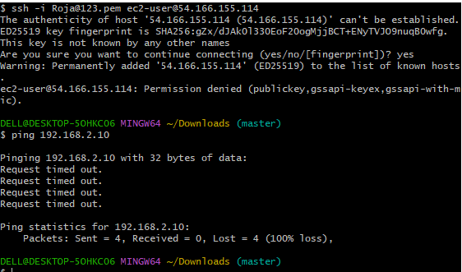
Verified route table in us west region to see local and peering connections
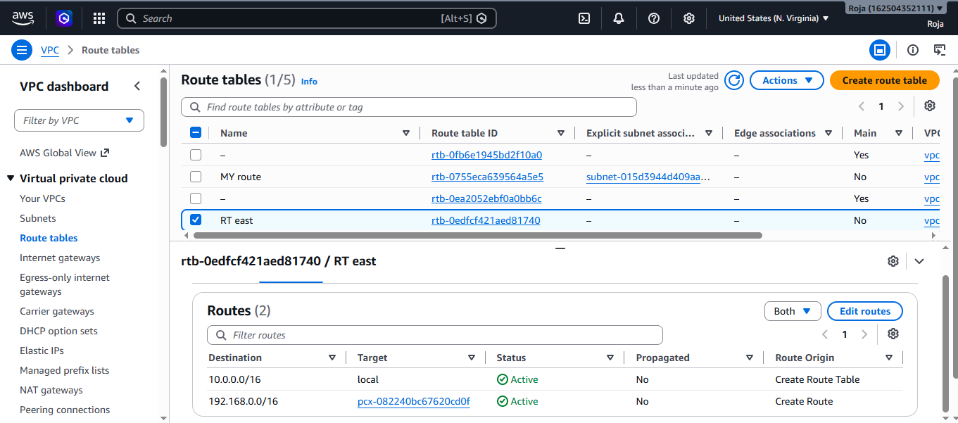

Verified route table in us east region to see local and peering connections
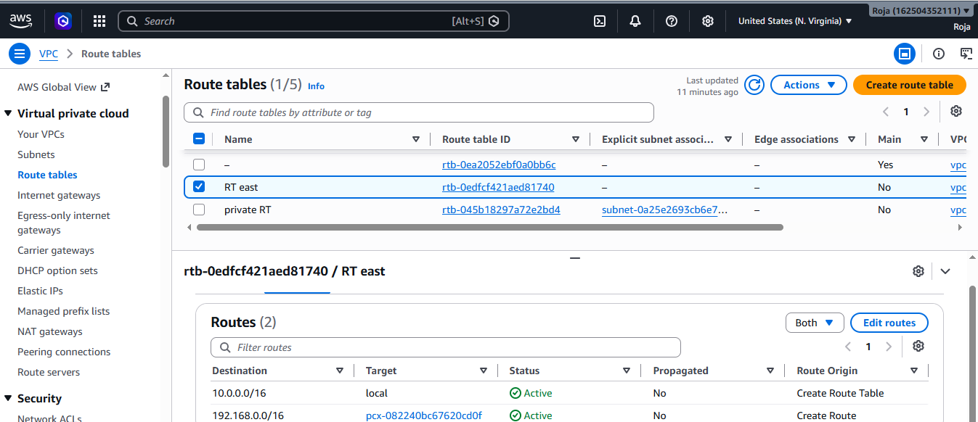

Task: 3 Enable VPC peering for cross-account (you can collaborate with your friend to do this task).
Objective
To establish a cross-account VPC peering connection between two Amazon VPCs that belong to different AWS accounts, enabling private communication between resources in both VPCs.

Prerequisites
- Two AWS accounts (Account A and Account B)
- Access to the AWS Management Console for both accounts
- One VPC in each AWS account
- Non-overlapping IPv4 CIDR blocks for both VPCs
- Appropriate IAM permissions to create and accept VPC peering connections
- A collaborator (friend) with access to the second AWS account
VPC-A VPC-A (Requester) | Account A | us-east-1

172.16.0.0/16 172.16.0.0/16 VPC-B (Accepter) | Account B | us-east-1 | 192.168.0.0/16

Step-by-Step Procedure

Step 1: Create VPCs

In Account A
- Log in to the AWS Management Console.
- Navigate to VPC Dashboard.
- Click Create VPC.
Name | VPC-A
IPv4 CIDR |  | 172.16.0.0/16
4. VPC created in region eu-north -1

VPC-A created successfully:
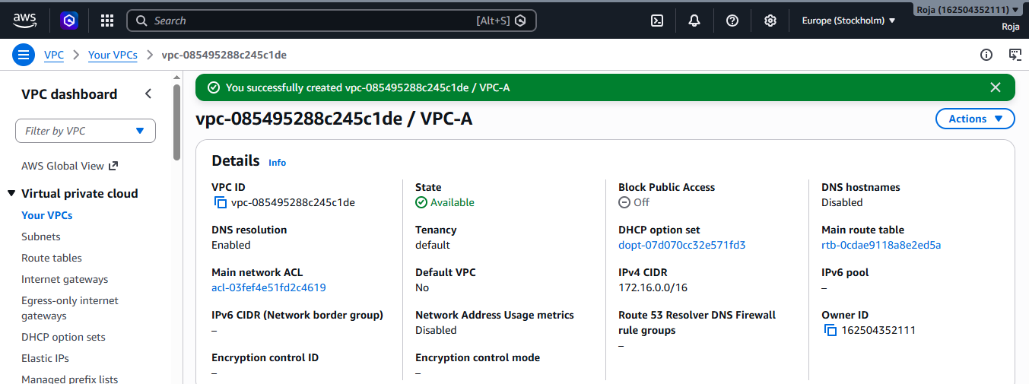

In Account B (Friend's Account)
- Log in to the AWS Management Console.
- Navigate to VPC Dashboard.
- Click Create VPC.
Name | VPC-B

IPv4 CIDR | 192.168.0.0/16
4. VPC created in region eu-north -1
Step -2 Exchange the following details with your friend
AWS Account Id, Aws region, VPC ID, VPC CIDR Block

Step-3 Create the VPC Peering Request
In Account B:
- Ask your friend to create a Peering connection
- Open VPC Dashboard.
- Click Peering Connections.
- Click Create Peering Connection.
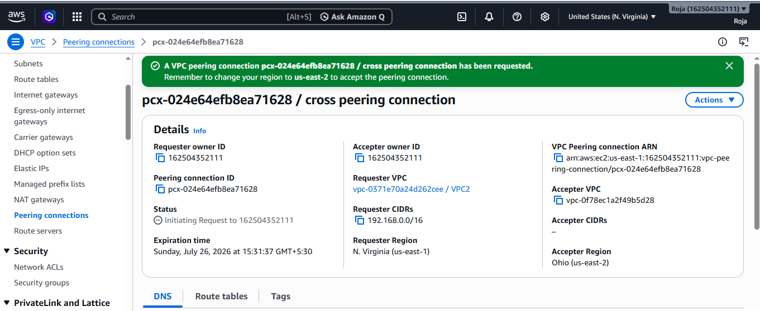

Step:4 Accept the Peering Request
In Account A:
- Choose the pending request.
- Click Actions → Accept Request.
- Confirm the request.
Expected Result: The peering connection status changes to Active.

VPC-A Received the peering request:
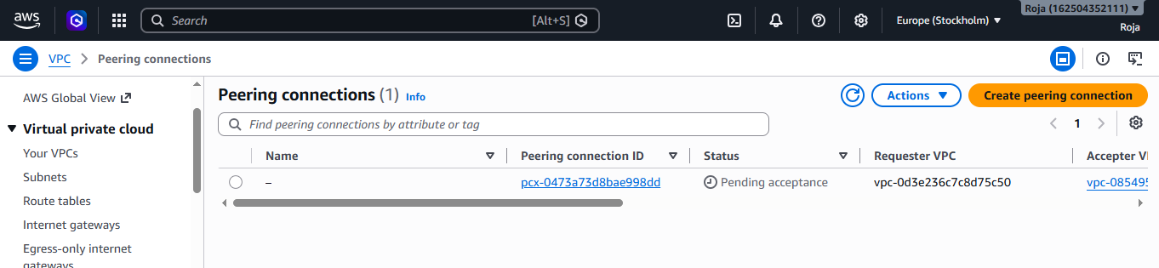
Accepted the request:
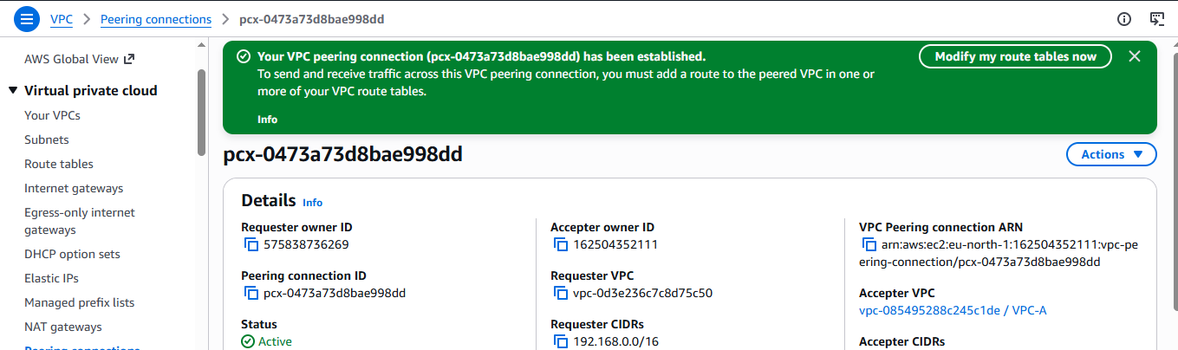
Create a public subnet with CIDR range 172.16.0.0/24:
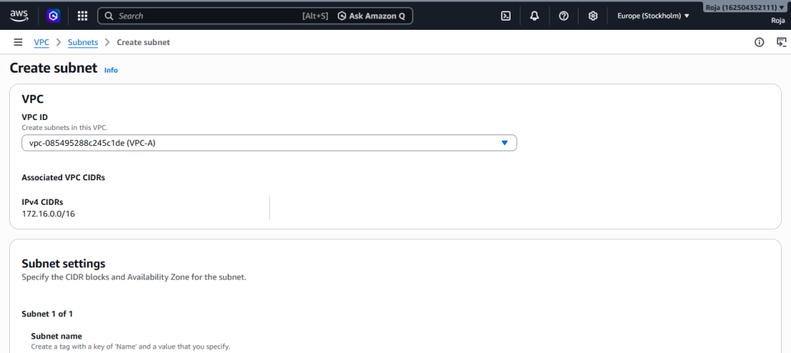
Create a route table associated with VPC-A:
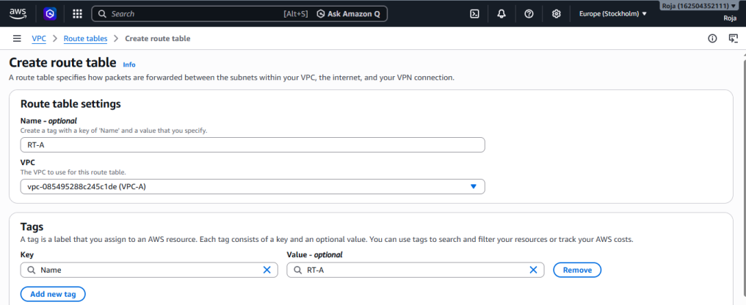
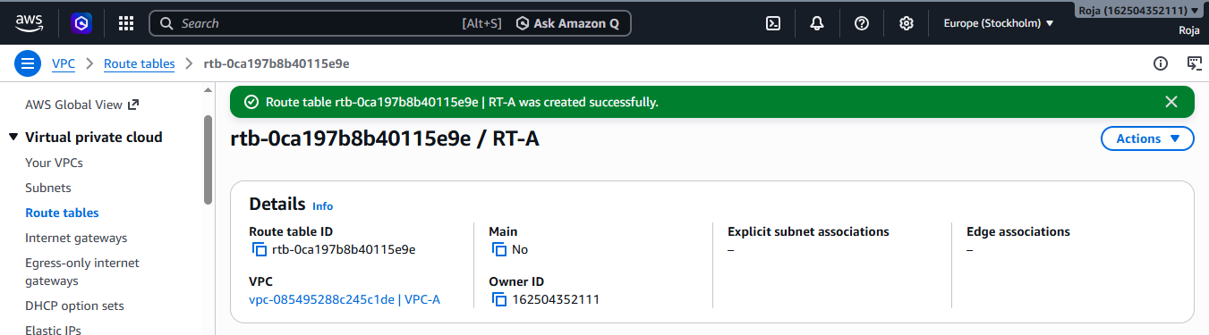
Successfully updated subnet associations to the route table:
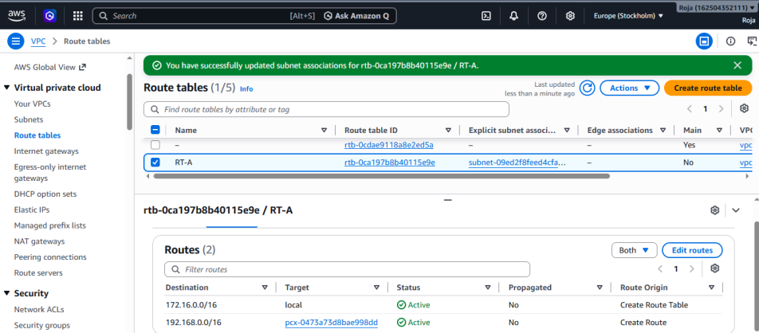
Added peering connection to route table:
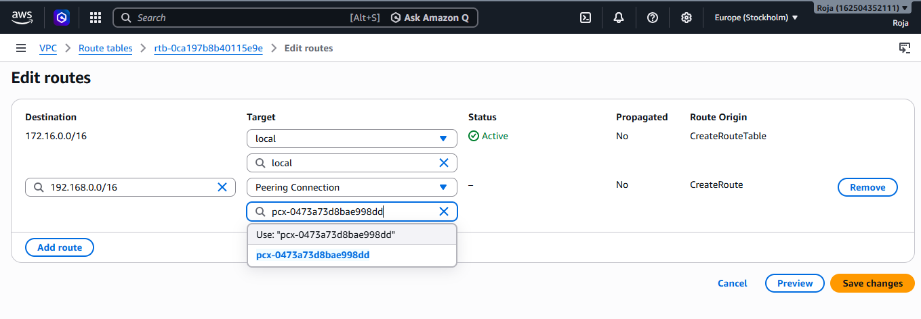
Created an Internet Gateway and attached to VPC:
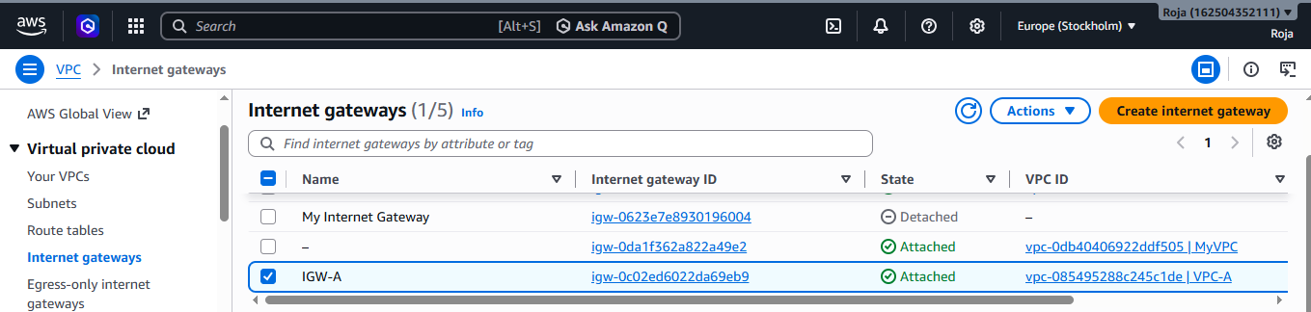
Launched an instance:
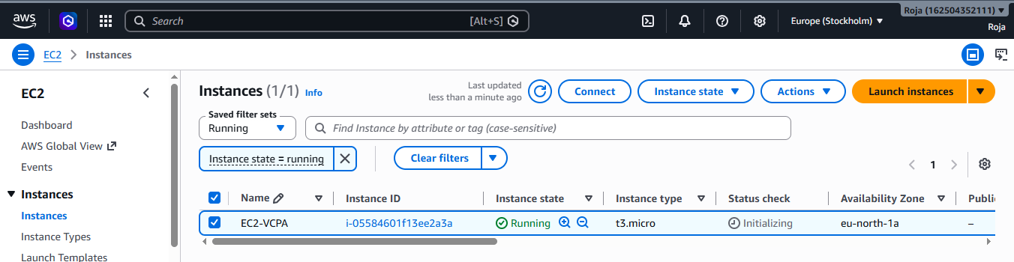
Verified the connectivity: 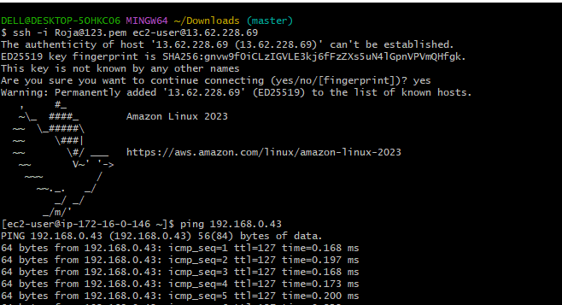

Task : 4. Set up a VPC Transit Gateway.
Step 1: Log in to AWS Management Console
- Log in to the AWS Management Console.
- In the search bar, type VPC.
- Click VPC under Services.
Step 2: Open Transit Gateways
- In the left navigation pane, scroll to Transit Gateways.
- Click Transit Gateways
Step-3: Create Transit Gateway
Enter the details
Step-4 Wait for Attachments to Become Available
- Open Transit Gateway Attachments.
- Verify that both attachments show the status Available.
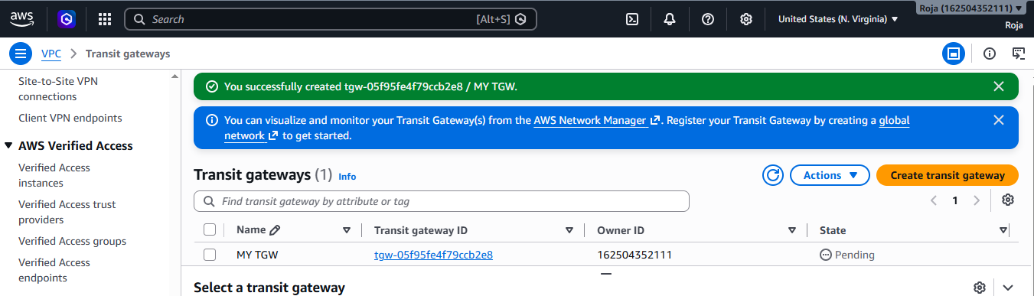
Transit Gateway attachment created for VPC1
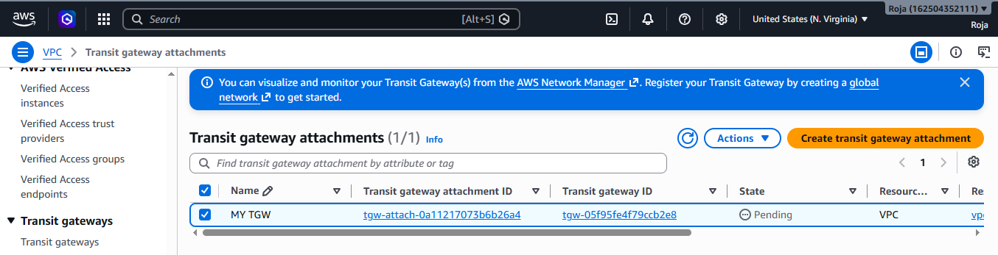

Transit Gateway attachment created for VPC2
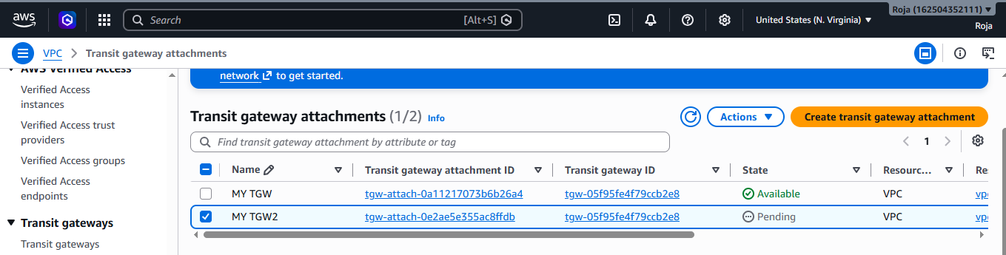

Task: 5 Set up a VPC Endpoint.

Objective
To create a VPC Endpoint that enables resources within a Virtual Private Cloud (VPC) to securely access AWS services without requiring an Internet Gateway, NAT Gateway, VPN, or Direct Connect connection.

Prerequisites
- AWS Account
- AWS Management Console access
- An existing VPC
- At least one subnet in the VPC
- Appropriate IAM permissions to create VPC Endpoints

Step-by-Step Procedure

Step 1: Log in to AWS Management Console
- Sign in to the AWS Management Console.
- Search for VPC and open the VPC Dashboard.

Step 2: Open the Endpoints Page
- In the left navigation pane, click Endpoints.
- Click Create Endpoint.
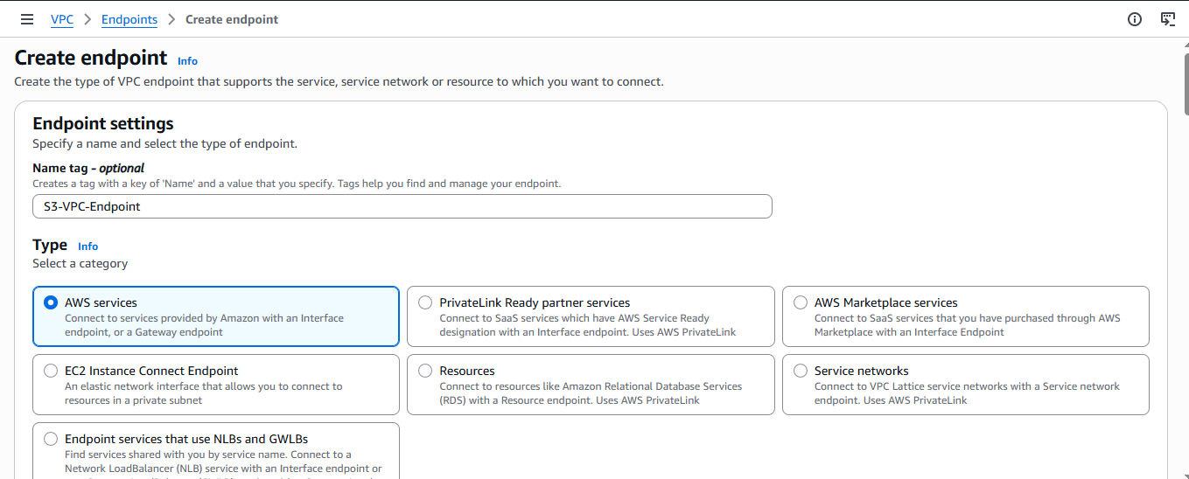

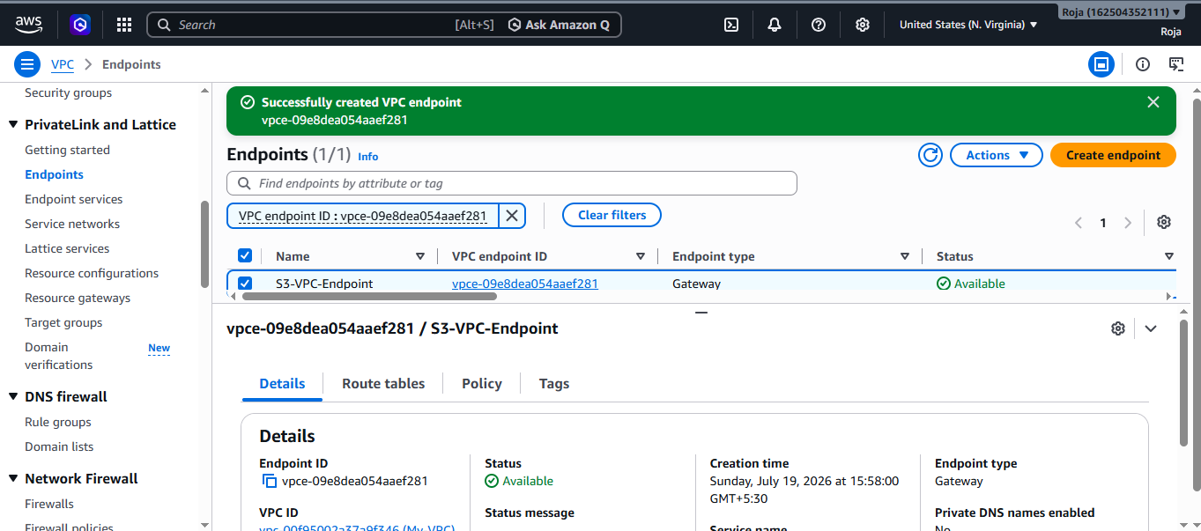

Step-3 Verify Route Table
- Open Route Tables.
- Select the route table associated with your private subnet.
- Click the Routes tab.
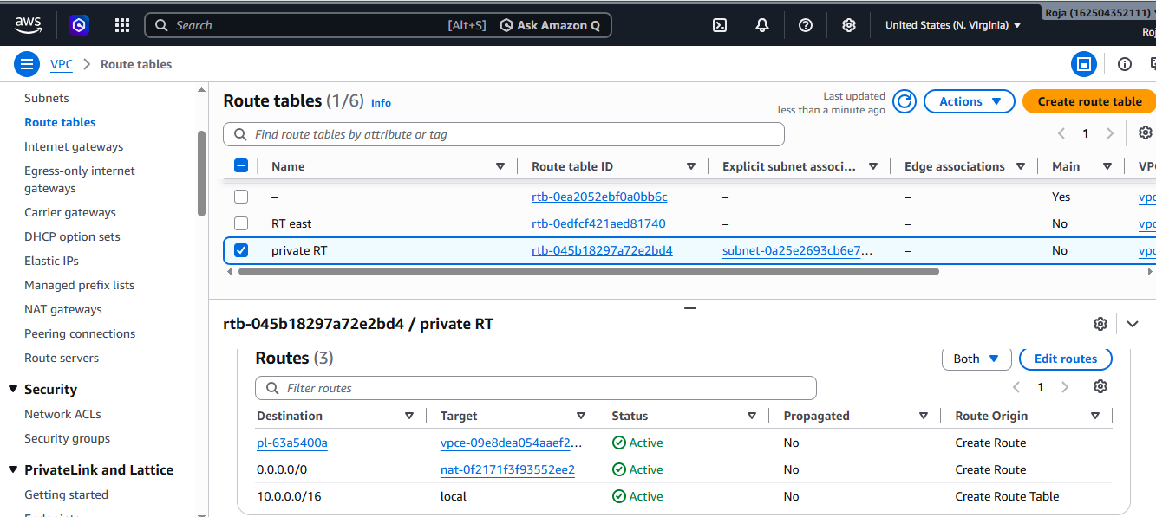

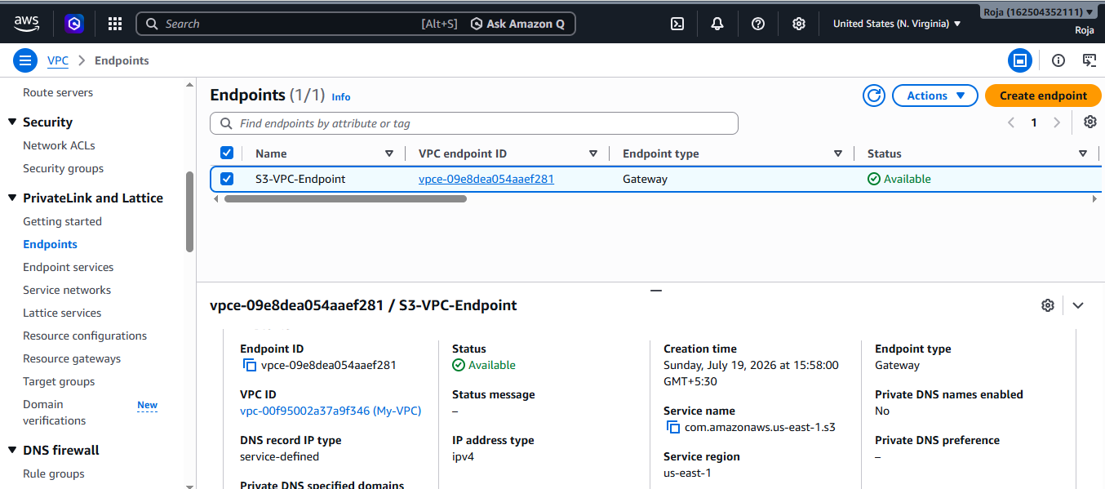
Step-4 Create IAM role
Sign in to the AWS Management Console.
1. Open IAM role
2. Click Create role.
3. Select AWS service
4. Choose EC2.
5. Click Next.

Attach a policy:
1. Attach a policy AmazonS3ReadOnlyAccess (to list buckets).
2. Give role name: EC2S3Role
3. Click Create role

IAM role created:
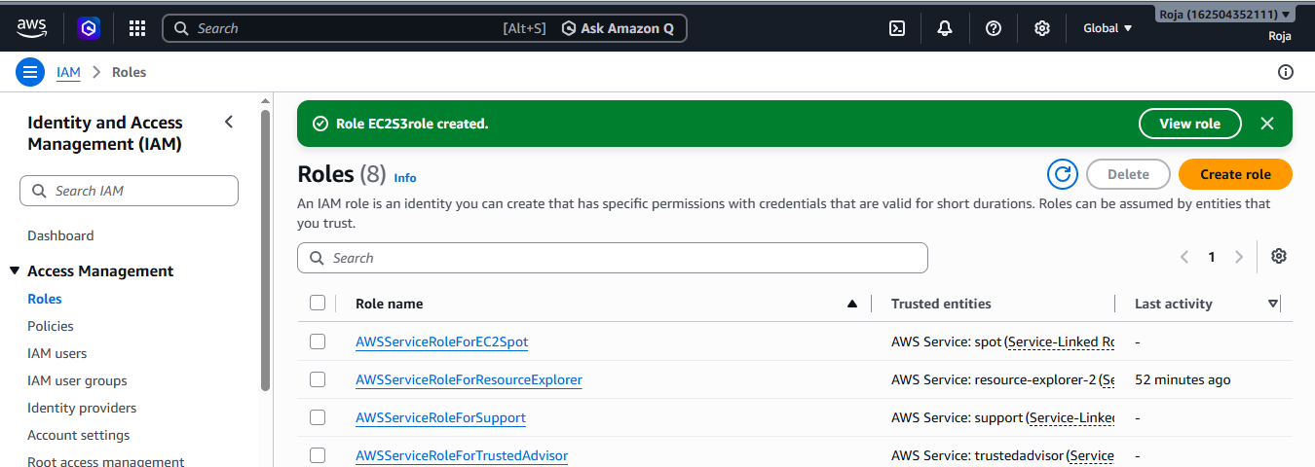

Attach IAM role to ec2 instance:
- Open the EC2 service.
- In the left navigation pane, select Instances.
- Select the EC2 instance to which you want to attach the IAM role.
- Choose Actions → Security → Modify IAM role.
- From the IAM role dropdown, select the desired IAM role.
- Click Update IAM role.
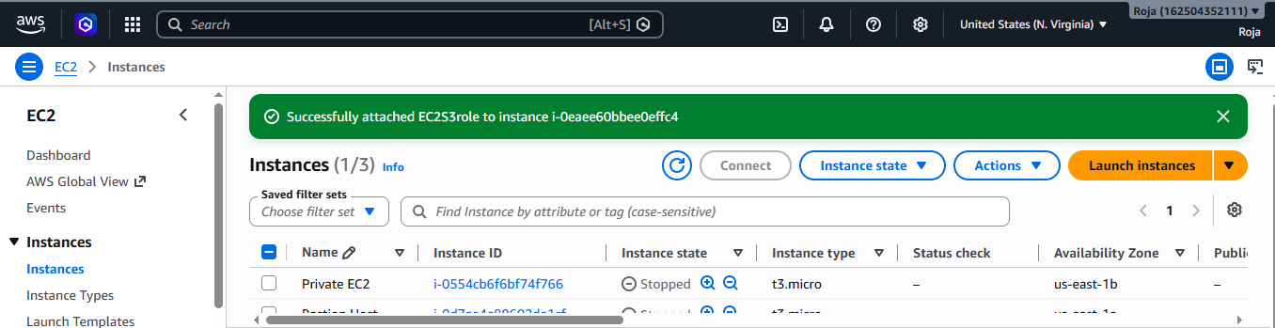

Connect to instance using ssh -i pemkey.pem ec2-user@public ip and checked the connectivity
